
Assigment # 01
Cloud Computing
Department of Software Engineering
Submitted By:
Name: Rafia Fiaz
Roll No: 2023-BSE-051
Class & Section: BSE 5-B

Submitted To:
Sir Waqas Saleem
----------------------------------------------------------------------------------------------------
Task 1:
Run Gitea in Codespace and Create an Initial Repo
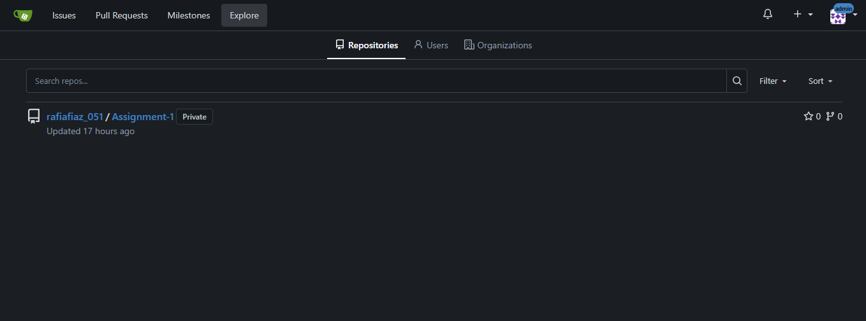
- New repository on gitea server:
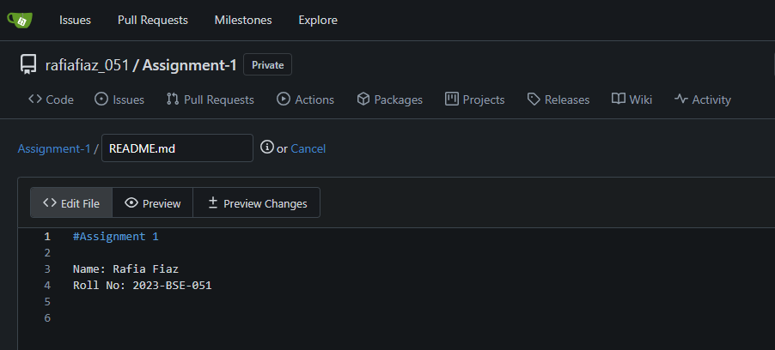
- Added README.md file on gitea repo:

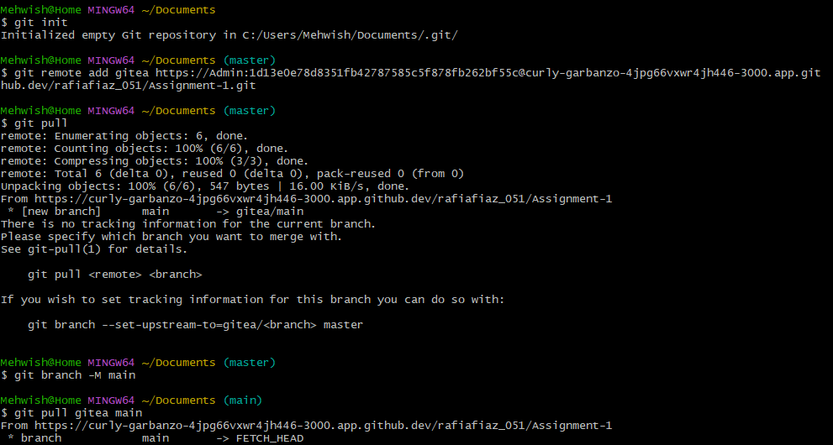
- Connection with gitbash:

- Checking README.md exists in local branch:
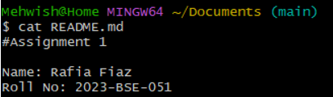
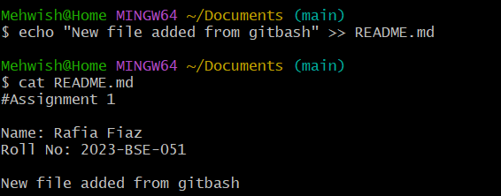
- Added another line in README.md:

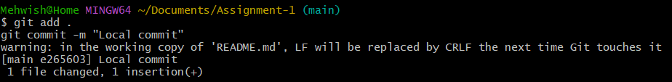
- Commit

- Push to gitea:
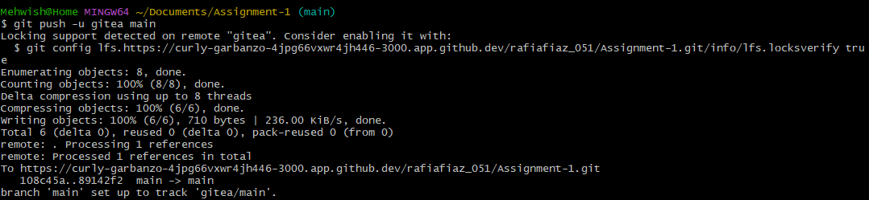
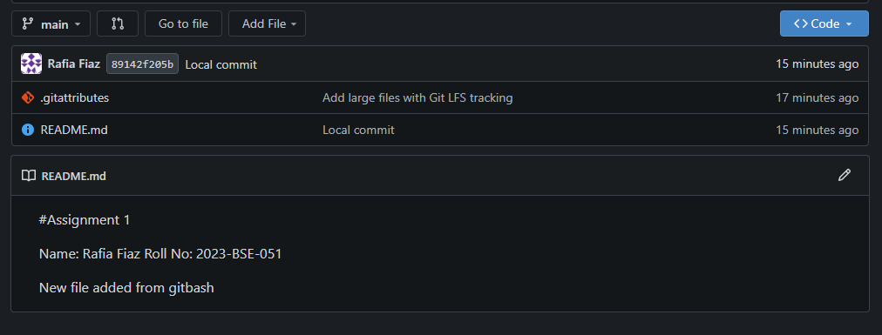
- Local Commit is shown on gitea GUI:

Task 2:
Mirror README.md from Gitea to GitHub
- Created a github Repository “Assignment-1”
- Added GITHUB as a second remote:

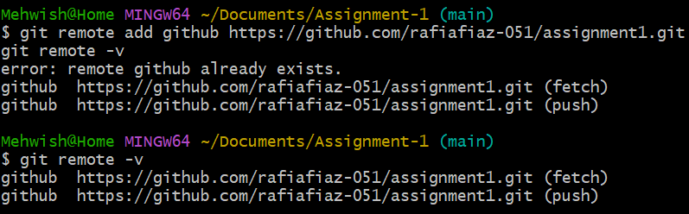

- Pushed README.md to Github:
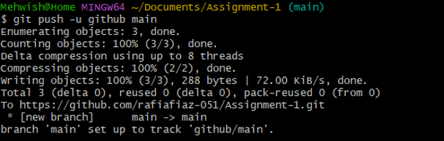

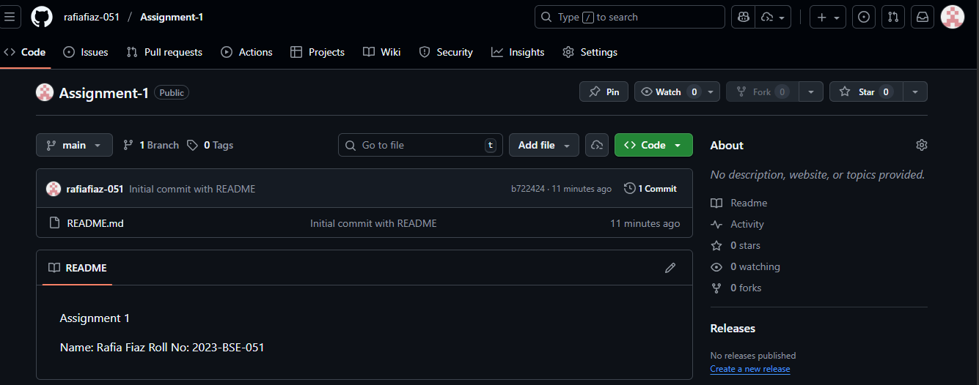
- Verifying README.md is pushed to Github repo:

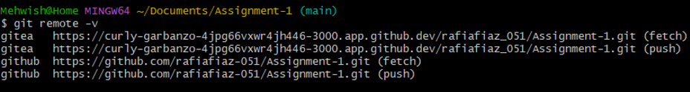
- Showing both remotes i.e; Gitea & Github:

Task 3:
Use Git LFS for Large Files
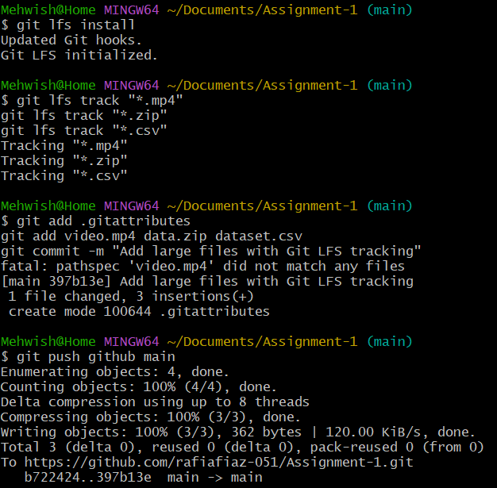
- Installed Git LFS & Added large files:
- Reference in Assignment-1 repo:
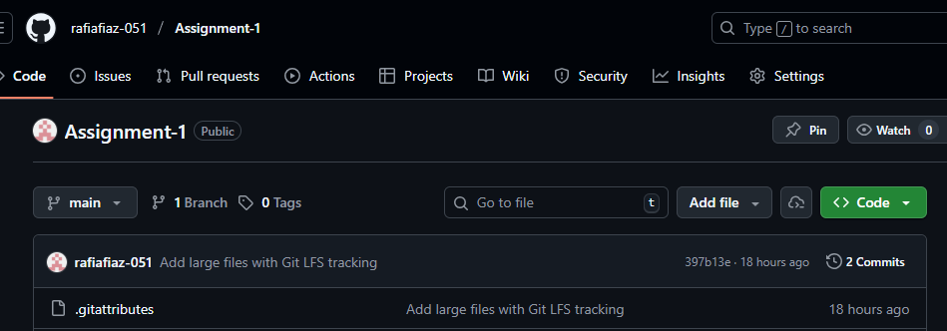
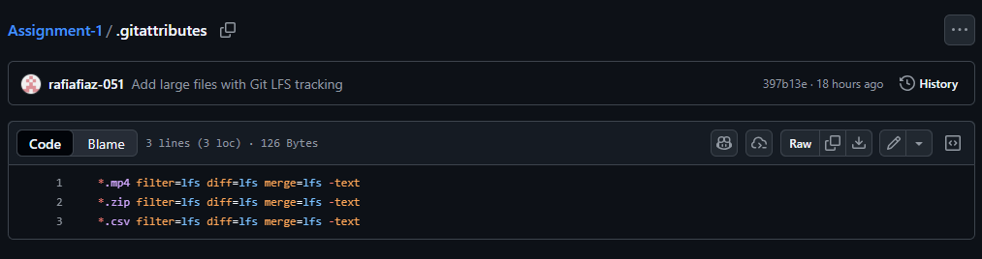
Task 4:
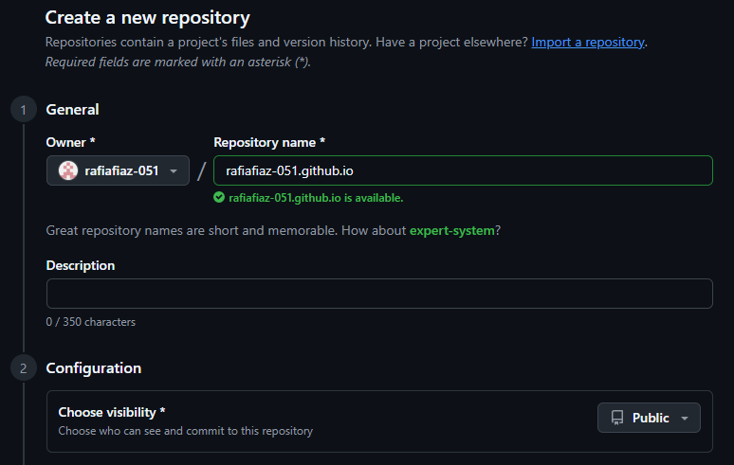
Create a Portfolio/CV with GitHub Pages
- Designed Portfolio & pushed into ‘rafiafiaz-051.github.io’ repo:
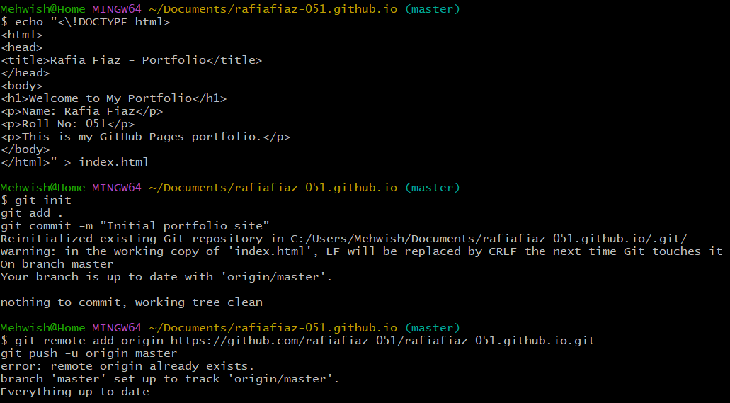
- Published Site:
